

Practical No: 2

Date: 28th September 2026

Title: Transistor Sampling

Name: David Tapia

Course: Bachelor of Engineering in Electronic Engineering

Subject: Digital Communications and Transmission

Lecturer: Ben Graham

Summary:
In this lab we are investigating the difference between analogue and digital signals. Using excel we will produce an analogue signal and then create a digital representation.

Objective:

To set up sampling and reconstruction circuits to study the sampling theorem and to plot waveforms for different sampling rates.
After the completion of this experiment, students will have good knowledge of
sampling, effect of sampling rate, method of sampling and reconstruction of signals.

COMPONENTS AND EQUIPMENTS REQUIRED:
BC547 NPN Transistor
CD 4066
Resistors – 8.2K Ω, 1K Ω ,470 Ω and 220 Ω
Capacitor- 1µF
Signal Generators.
Oscilloscope
Bread Board
Wires and probes

Theory:

As a first step to convert any analogue signals into digital form, samples of the analogue signals are taken at regular intervals. The levels of these samples are then encoded and sent to the receiver. Today this sampling and encoding is typically performed using an Analogue to Digital Convertor (ADC).

At the receiver these samples are recovered and from that the original signal is reconstructed.

A basic sampling and reconstruction circuit is shown in Figure 1. A transistor is used as a crude analogue switch to take samples of the sine wave input. Sampling pulses are applied to the base of the transistor that switches it ON and OFF. The input signal is sent to the output only when the transistor is ON. Thus the output of the transistor is a sampled form of the input signal.

The reconstruction circuit is a low pass filter having a cut off frequency equal to the frequency of the analogue input signal.

Procedure & Results:

Para empezar, se recreó el circuito en CircuitMaker, como no se tenía conocimiento previo del programa, se aprendió a utilizar los elementos básicos de el mismo. Una vez se recreó el circuito se configuraron los generadores de señales para emitir una onda senoidal y una onda cuadrada con ancho de pulso del 50% respecto a su periodo. Estas corresponden a la señal analógica y la de muestreo respectivamente.
Una vez configuradas, se dispuso a revisar las diferentes señales evaluando el circuito en diferentes puntos.
Finalmente se varió la frecuencia por encima y por debajo de los 250 Hz y se comprobaron las sample output signal y reconstructed signal en el osciloscopio.

Results

Understanding of Nyquist sampling rate
The Nyquist sampling rate dictated that for the correct sampling of a signal, the sampling frequency had to be at least twice the highest frequency of the signal. This was to ensure that all necessary information was captured and to avoid the error of aliasing, in which the frequencies overlapped. This could be observed when the signal was tested below 250 Hz, where fewer and wider samples were verified per cycle, failing to adequately track the shape of the original 20 Hz sine wave. Consequently, the filter could not reconstruct the initial waveform, demonstrating that once aliasing occurred, the initial signal could not be recovered.

Estimate the phase change between the original waveform and the reconstructed waveform
Para realizar el cálculo teórico primero calcularemos Xc. Para ello usaremos la resistencia R3 y el condensador C1 como se puede ver a continuación.
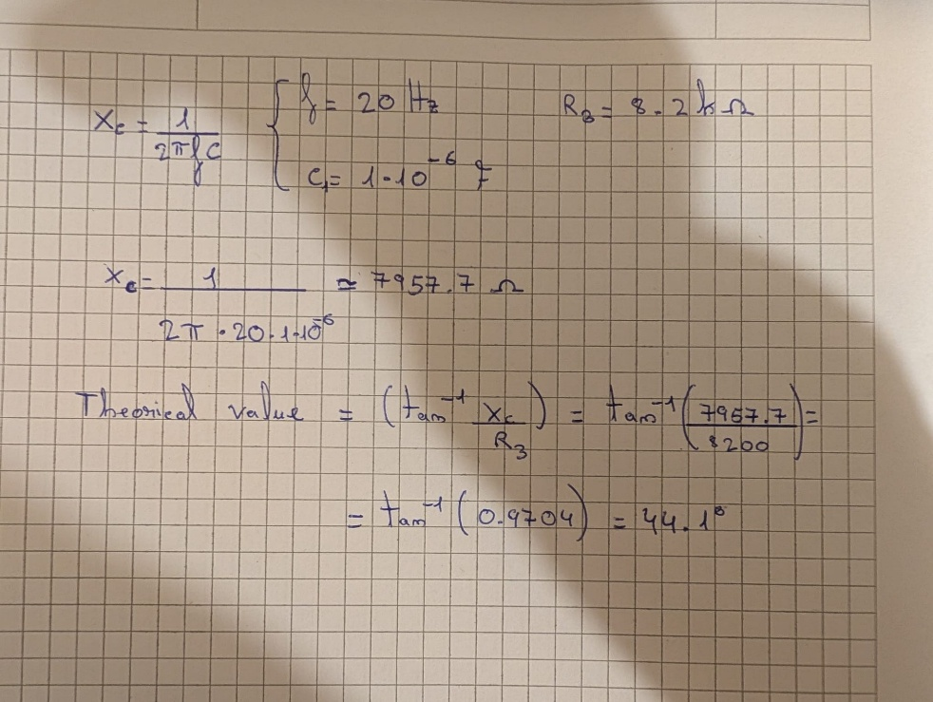
Figure 1: Calculation of the theorical value

Circuit Diagram:
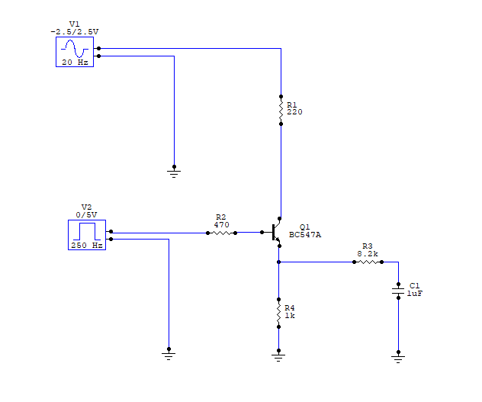
Figure 2: Diagram in CircuitMaker

Waveforms:

Analogue input signal:
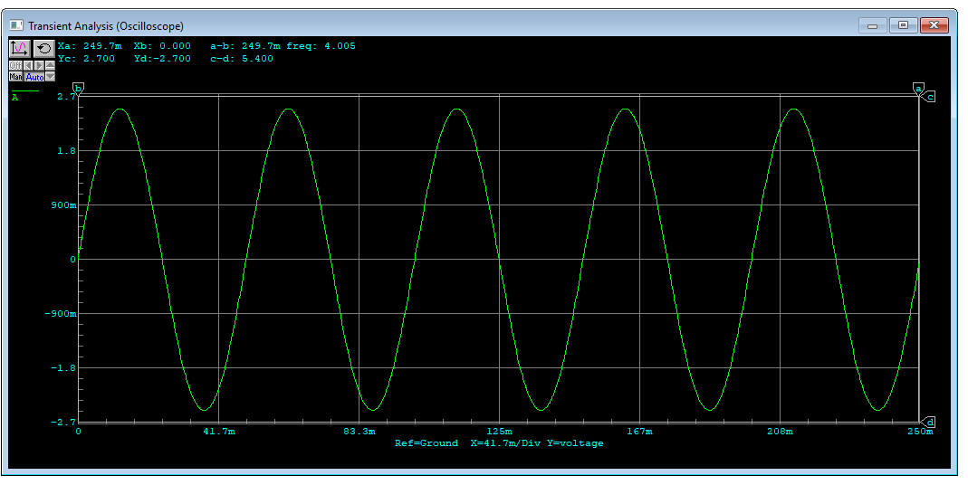
Figure 3: Analogue input signal wave

Sampling signal:
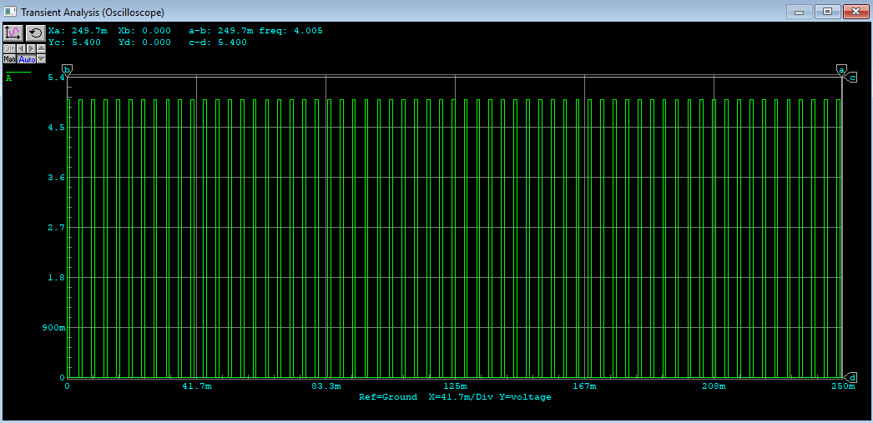
Figure 4: Sampling signal wave

Sampled output:
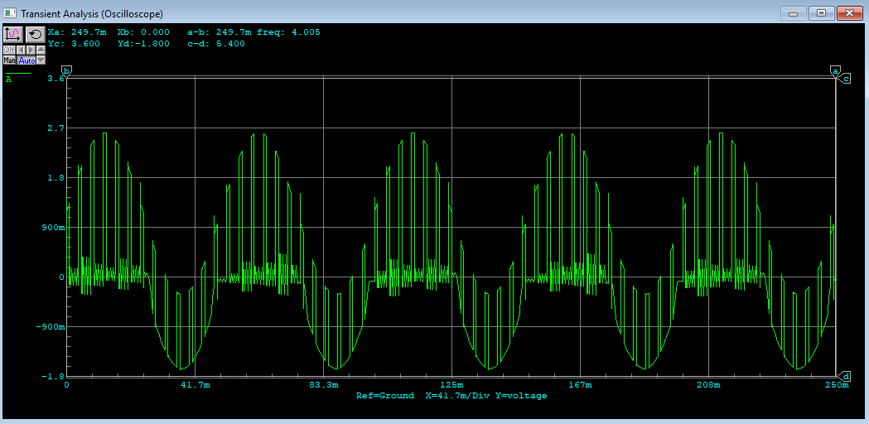
Figure 5: Samplet output wave

Reconstructed Signal:
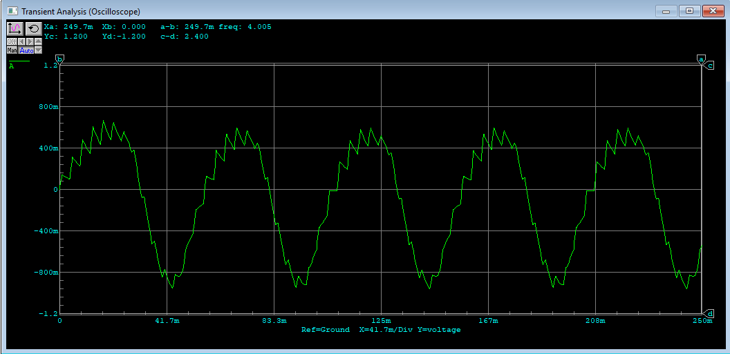
Figure 6: Reconstructed Wave

The diagram has been recreated in CircuitMaker, and all waveforms have been analyzed. The wave was sampled using 1 ms wide pulses, as can be observed in Figure 4. Upon passing the wave through the DAC, we can see that the resulting wave (see Figure 5) is similar to the initial analogue wave (see Figure 2), although with slight alterations due to the components not being ideal.
Falta de pregunta 5 en adelante

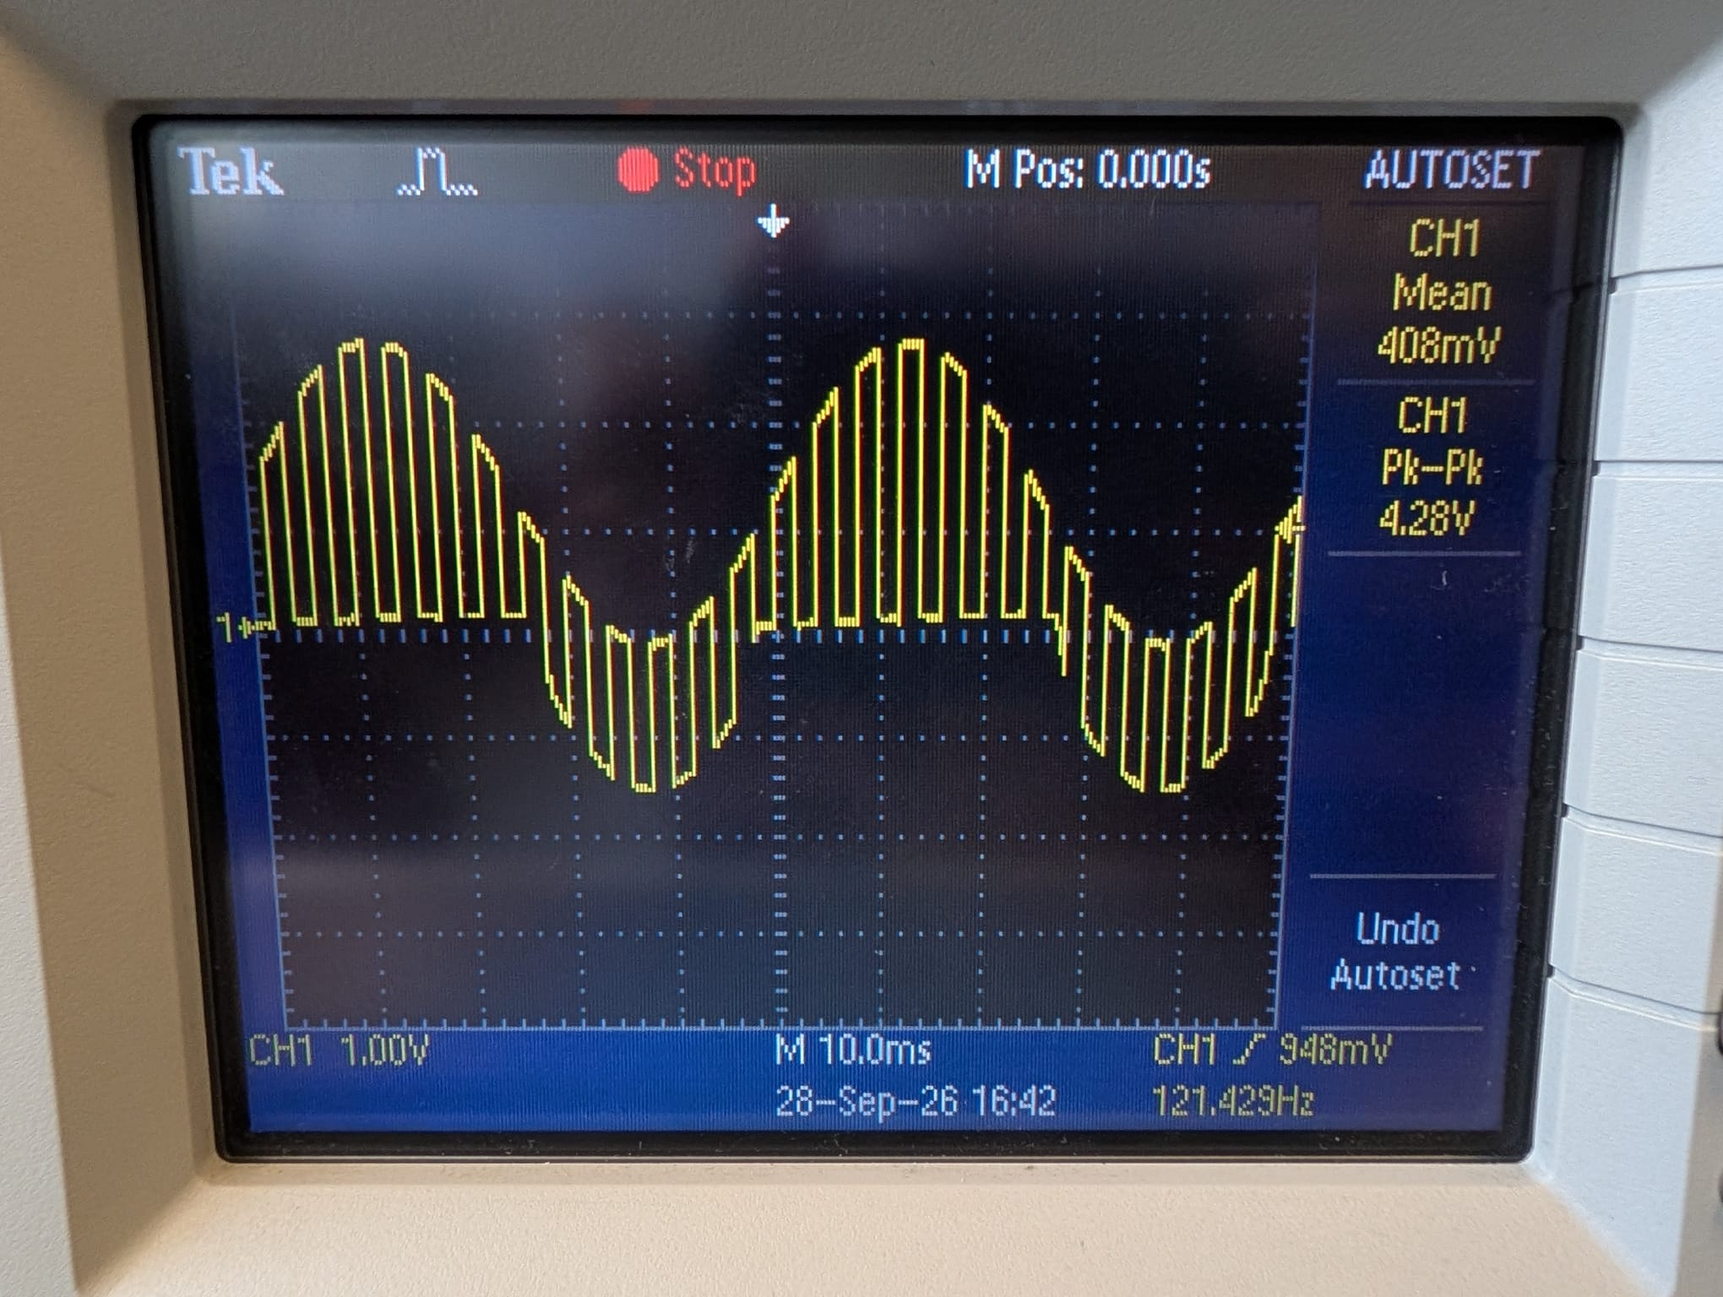
Figure 7: +250Hz Sample Output Diagram

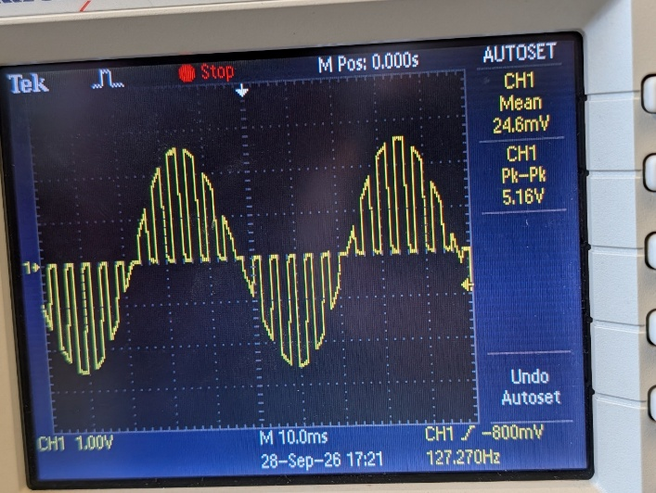
Figure 8: -250Hz Sample Output Diagram
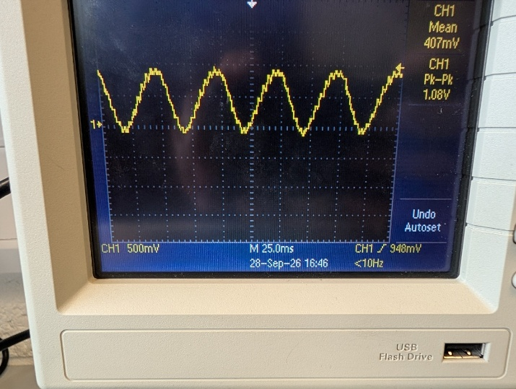
Figure 9: Reconstructed Wave

Conclusion:

Explain your results any errors, sources of improvements, any points of interest during the lab.
Laboratory Report Guidelines

The objective of a laboratory report is to communicate the details of a piece of work to a third party, in such a way that should they wish, they could repeat and verify your work. It is the task of the report writer to structure the information into a format appropriate to the target audience. The previous pages are a useful guide to the structure of a formal technical report. Report should be submitted in both word and pdf versions.

Page1

Lab Number
Date
Title (not more than 2 lines)
Name
Course
Subject
Lecturer
Summary (not more than 3 lines saying what the lab is about)

(See example sheet)

Page 2

Objective: The aim of the experiment.
Equipment used: A description of any equipment/components used.
Theory: A brief explanation of background principles on which the lab is based.
Procedure: Step by step explanation of how the experiment was carried out, past tense.
Results: Data, tables or computer printout, graphs etc, show all calculations, final outcomes, percentage errors etc.
Ensure any oscilloscope images are maximum to fill the oscilloscope screen, use markers/cursors on oscilloscope when presenting measurements.
Oscilloscope screenshots can be saved to USB pen drive or a picture taken with phone. Any photo screenshots should be straight, clear and cropped appropriately to show only the oscilloscope screen. Use cursors on oscilloscope to take measurements..

Last page
Conclusion: In your own words why what happened, what you have seen or proven, reasons for success or failure, suggestions for improvement, sources of errors etc.

Digital Communications and Transmission Lab Report Marking Rubric

Standards | > 80% | 65% – 80% | 40 – 65% | < 40% Fail
General Report Layout  (Weight: 10%) | Follows the formal report template structure. Third – person used throughout. | Clear progression through all sections of the draft report. Minor errors, referencing, etc. | Mixes third- person and first. Presentation and structure is inconsistent. Some grammatical or formatting errors. | Hard to follow, fails to follow the report structure. Incomplete, fails to meet basic academic/technical standards.
Procedure / Methodology  (Weight: 30%) | Clear, concise summary of the procedure and methodology. Possible used schematics and images to explain, perfect labelling. In depth knowledge presented | Covers the main steps and setup accurately. Minor details or omissions from diagrams, etc. | Simply copied the lab sheet text without showing personal understanding. | Omits critical steps/sections, unrecognizable, missing entirely.
Data Presentation & Accuracy  (Weight: 30%) | All data presented in a clear and clean manner. Images cropped with image reference used. Correct units used, clear axes, titles used on graphs. Any references included. | Data is accurate and structured. Minor incorrections in units, labelling, axis, etc. | Data is present but disorganized. Units missing, visually poorly presented. Minor calculations error. | Calculations wrong, fabricated data, completely missing data. Unacceptable level of data presented.
Discussion & Error Analysis  (Weight: 30%) | Deep evaluation provided between experimental and data. Clear understanding of sources of error, measurement uncertainties or equipment tolerances. Deep knowledge of the subject. | Correctly compares results to theoretical values. Identifies errors but doesn’t present critical insight.  Knowledge of the subject. | Notes any gaps between theory and results, without discussion or simply blamed as human errors.  Limited knowledge of the subject | No interpretation or engineering context.  No discussion

